OSCAR
Ohio School Counselor Accountability Report
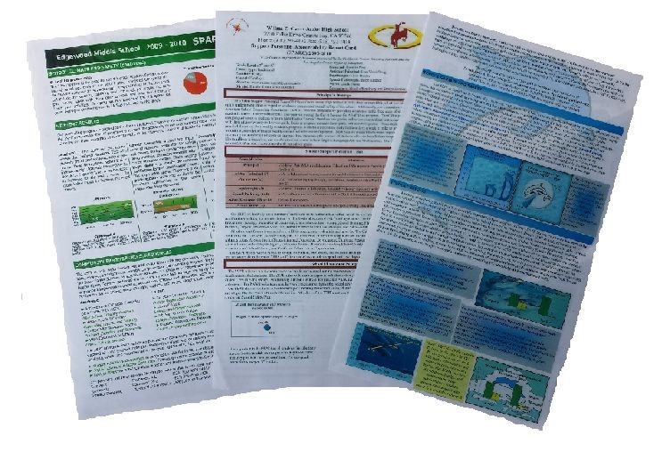
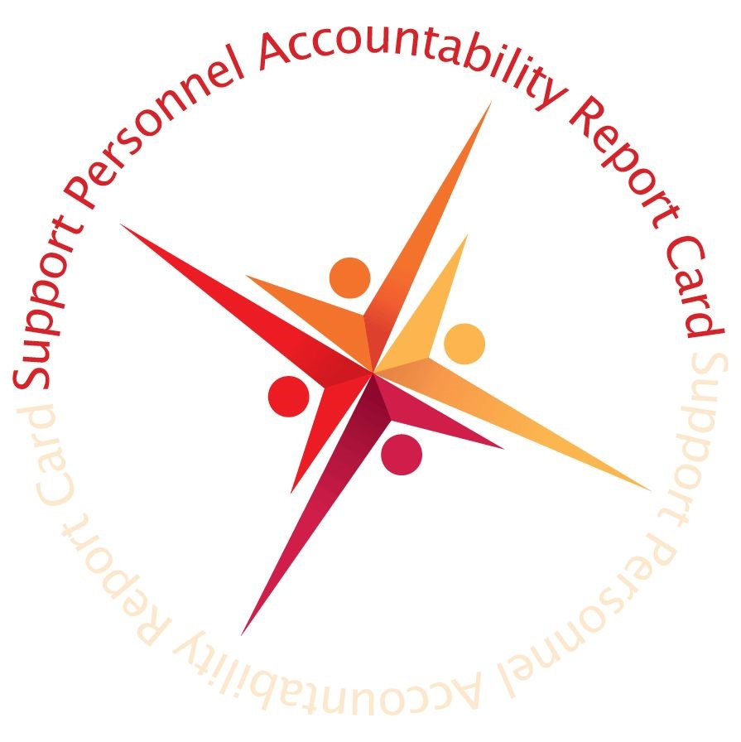
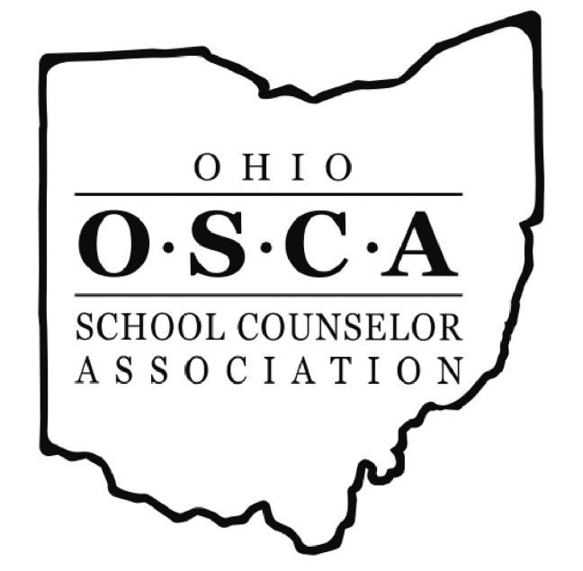

Development Manual for OSCAR Creation
A Continuous Improvement and Advocacy Tool for School Counselors

Guidelines

The Ohio School Counselor Accountability Report (OSCAR) is a results-based representation that visually demonstrates how student domain outcomes are facilitated by the work of school counselors. School counselors are educators with Masters Degrees, who work with the entire student population on their academic, career, and social/emotional development in collaboration with parents, administration, and teachers.

This manual is designed to support school counselors in creating a high quality document for publication, and we encourage school counselors to submit them for an award from the Ohio School Counselor Association by visiting​ ​http://ohio.schoolcounselorawards.org/​ ​in the Other Awards section​. Each section of the OSCAR is broken down below, along with helpful hints. Reference the rubric below to ensure you have all of the recommended sections and details to qualify for an OSCAR award. A user-friendly template has been provided to help streamline your OSCAR development. It should be noted this template is just a suggestion, and the sky is the limit when it comes to artistically designing your OSCAR.

The application MUST also include the following information on a cover sheet:
- Applicant name(s)
- Applicant email address (es)
- Building principal name/ email address
- Superintendent name/email address

An award-winning OSCAR must include ​ALL​ ​six ​sections and ​include one of the Ohio School Counselor standards in each of the first five sections:

1.) The ​Principal’s Message​ is a personal message to your school community about the vital role of the school counselor in the school. The message should be tied into the local/district/state/national initiatives as appropriate and tied to the school mission/vision statement. In this section, the school counselor’s involvement in programs can be highlighted. It can also include a description of the learning environment, school community description, building improvement plan, school improvement plan and/or include focus for improvement. Limit 250 words​. ​(Must include Ohio School Counselor standard.)

2.) The Professional School Counselor Statement​ is a message from the counselor(s) in the building. The​ message focuses on the role of the school counselor and the program. ​Limit 300 words. (Must include Ohio School Counselor standard.)

3.) The ​School Climate and Safety​ section includes process and perception data. Ask yourself, what does the community want to learn about school climate and safety and how does the school counselor play a role in school climate and safety? It could include information on preventative programs (i.e. bullying prevention and character education). ​Limit 250 words. (Must include Ohio School Counselor Standard 5.)
4.) The ​Student Domain Outcomes ​section shows the relationship between the school counselor and the American School Counselor Association’s academic, career, and social/emotional domains; it highlights how the work the school counselor impacts student outcomes and student achievement. ​(Must include Ohio School Counselor standard.)

5.) The​ Community Partnership/Resources​ section illustrates to your readers how connected the school counseling program is with agencies, businesses, schools and other resources. ​(Must include Ohio School Counselor standard.)

6.) The ​Student Support Personnel Team ​section shows whom the school counselor works closely with and lists years of experience and education (Masters, Doctorate etc.) (​Does not​ have to include Ohio School Counselor standard.)

OSCAR submissions will be accepted and reviewed one time during the year​, with due date of ​April 30​. Please​ request a review no later than 3/30. After the OSCAR committee has approved your report, you will have the opportunity to be recognized at the All Ohio Counselor Conference and your document will receive an official OSCAR designation. If your OSCAR does not have all of the recommended details, you will receive feedback and recommendations for revision​. All submissions must be uploaded in PDF format to http://ohio.schoolcounselorawards.org/​ under Other Awards.

After receiving an OSCAR, your document can be used as an advocacy tool for your school counseling program. Distribute your OSCAR to key stakeholders including your building and district administration, school board members, advisory council, parent associations, local and state legislators and any other individual or group which may have a vested interest in your school counseling program. Posting your OSCAR on your school website and/or other social media outlets is also encouraged.

Rubric
The rubric is designed to determine if your OSCAR has all of the recommended details, as endorsed by the Ohio School Counselor Association. Please use this rubric as a guide in the development of your award-winning OSCAR. All ​six​ sections are now mandatory. ​Sections 1-5 must include one Ohio School Counseling Standard.

Section 1: Principal’s Message

Describe the role of the Professional School Counselor in promoting student academic, career and personal/social readiness. (Limit of 250 words)

Principal’s Message | Yes | No
Must include a statement on the School Counselor(s) efforts to support all students in academic, career and personal/social development. | ☐ | ☐
Must include two (2) focus-for-improvement goals that relate to the academic, career or personal/social domains. | ☐ | ☐
Please add school mission statement and include and Ohio School Counselor Standard | ☐ | ☐

Section 2: Professional School Counselor Statement

Describe your role in promoting student academic, career and personal/social readiness. (Limit of 300 words)

Professional School Counselor Statement | Yes | No
Must include a statement about the school providing an equitable student support system to prepare students for academic, career and personal/social skill development. | ☐ | ☐
Must include information regarding the academic degrees, years of experience and memberships in professional associations for each school counselor in the school. | ☐ | ☐
Must include a statement describing who the Professional School Counselor coordinates services with on a regular basis. | ☐ | ☐
Includes one of the Ohio School Counselor Standards | ☐ | ☐

Section 3: School Climate and Safety (Must use Ohio School Counselor Standard 5 in this section.)

Provide evidence and documentation of the impact of the Professional School Counselor in promoting a positive school climate and school safety. (Limit of 250 words)

School Climate and Safety | Yes | No
Must include a statement explaining the importance of school climate and safety. | ☐ | ☐
Must include a statement about the use of the school safety plan. | ☐ | ☐
Must include a graph or chart reflecting data related to student safety. | ☐ | ☐
Must use Standard 5 (Ohio) | ☐ | ☐

Section 4: Student Domain Outcomes
Provide evidence documenting the impact the Professional School Counselor is having in promoting student academic, career and social/emotional readiness.

Student Domain Outcomes | Yes | No
Must include a statement explaining the importance of student outcomes and the relationship to the three (3) ASCA domains, including the standards: Academic Career Social/Emotional | ☐ | ☐
Must have one graph for each of the three (3) ASCA domains that illustrate student outcomes supported through efforts of the School Counselor. | ☐ | ☐
Includes an Ohio School Counselor Standard | ☐ | ☐

Section 5: Community Partnerships

Describe the school site programs and community partnerships that support the development of academic, career and social/emotional readiness skills. (Mandatory)

School Site Programs and Community Partnerships | Yes | No
Must include a general statement indicating the importance of community programs and partnerships at your school site. | ☐ | ☐
Must provide a chart that lists school site programs and community partnerships. | ☐ | ☐
Must provide the name, telephone number, and email of a person at your site for interested volunteers and community organizations to contact about becoming involved in academic, career and personal/social readiness school site programs and/or partnerships. | ☐ | ☐

Section 6: Student Support Personnel Team

Describe who is on the team, list education and years of experience. (Mandatory)

Lists position held, years of experience and education | ☐ | ☐

Miscellaneous
Additional important information to consider that must be included to be awarded an OSCAR.

Formatting | Yes | No
Is the document readable? Consider font size and color. (Arial or Times) | ☐ | ☐
Is the document visually appealing to the reader? Consider graphs and logos. (Must use OSCAR Banner. | ☐ | ☐

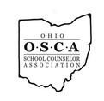 | Ohio School Counselor Accountability Report  (OSCAR)  A Continuous Improvement and Advocacy Tool sponsored by the  Ohio School Counselor Association

School Name:
[Insert School Logo] (Address)
(Phone number and Fax number)
(Website address)
DISTRICT:
GRADE LEVELS​:
ENROLLMENT:
Principal’s Message
PRINCIPAL​:
Insert Principal’s Message here

Professional School Counselor Statement
Insert Professional School Counselor Statement here
School Climate and Safety
Insert school climate information here
Insert school climate data chart here

Student Domain Outcomes
Insert Academic results and standards ere
Insert Academic data chart here

Insert Career data chart here
Insert Career results and standards here

Insert social/emotional data chart here
Insert social/emotional results and standards here

Community Partnerships

Career | Academic | Social/Emotional

Student Support Personnel Team
Student Support Team | Education/Experience | Description of Student Support Team

